COLLEGE OF COMPUTER STUDIES DEPARTMENT
THESIS PROJECT
TITLE PROPOSAL
(CS0025 – Software Engineering 1)

Group Name: Statisfied | Program:  Bachelor of Science in Computer Science  with specialization in Data Science
Member’s Name:  1. Dawn Andrei Pamesa (Project Manager)  2. Rogelio Porras (Member 1)  3. John Ashley Alba (Member 2)  4. Ralph Blanco (Member 3) | Term:  [✓] 1st [ ] 2nd [ ] 3rd | Academic Year:  2026 - 2027
Proposed Project Title 2:
Cash-Flow-Aware Prediction of Progress Billing Payment Delay for a Construction Firm Using Modified Gradient Boosting Loss

1.0 Area of Investigation:
Construction firms carry large upfront costs for labour, materials and equipment while payment arrives in progress billings that the client approves slowly. The firm says late collection and cash flow cause the most delay and loss, and that it decides pricing, manpower and scheduling mostly by experience. A model that tells the firm how many days each billing is likely to take would let it plan cash from data (Appel et al., 2020; Bahrami et al., 2020; Moore & van Vuuren, 2024).
The firm's three problems, in its own words, and the one chosen:
Problem | What the firm said | Status
1. Late collection and cash flow | Collection from the main client takes long; late payments and cash flow cause the most delay and loss. | CHOSEN. Slow collection from its main client and cash flow were named by the firm among its top problems in its questionnaire answers. The outcome (days to payment) can be checked against the firm's own dates.
2. Materials needed | Hardest to predict; weekly ordering from 5 suppliers. | Not chosen. Its records may be used as optional extra predictors.
3. Cost and schedule changes | Final cost differs from the estimate; permits, rain, changed decisions and site obstructions. | Not chosen. Its project change records may be used as optional extra predictors.

Payroll and manpower were also named, but they involve personal data and are outside the scope.
Algorithm/Technique Justification
Identified problem | Slow collection and cash flow: billings are paid later than the firm can plan for.
Computational task | Predict days to payment for each progress billing (regression); late-or-on-time is derived from the same prediction.
Proposed technique | Gradient boosting with a modified loss: weighted by billing amount and asymmetric, penalizing predictions that are too early more than too late (Bauer et al., 2024; Laimighofer et al., 2022; Masnadi-Shirazi & Vasconcelos, 2011). The unmodified version is kept as a control so the effect of the change is measured by itself.
Comparison | Variants A to H described in 2.0: the firm's average delay, gradient boosting with squared, absolute and quantile loss, amount weights only, asymmetric penalty only, both together (proposed), and one other algorithm (Egwim et al., 2021; Fouad et al., 2025; Moore & van Vuuren, 2024; Saini et al., 2024). The final list and its number depend on the literature.
Required data | About 2 years, up to the latest billing, with more than 500 progress billings, including billings not yet paid with the payment date left blank. Billing and payment dates, amounts and project for each progress billing, plus approval-stage dates if kept. Optional: material spending and project cost changes. No personal data.
Expected output | A predicted days-to-payment for each billing, a flag for billings likely to be late, and a plain comparison of the modified and unmodified models.
Evaluation | Expanding-window chronological evaluation over several forward windows, a final untouched test period (about 60% / 20% / 20% of the billings by billing date for training, validation and test), and no leakage (a payment outcome counts only once it is known). Metrics proposed with the algorithm: mean absolute error in days; the same weighted by billing amount; underprediction exposure U, meaning the billing amount times the days by which payment arrives later than predicted, added up (peso-days), and overprediction exposure O, the same for payment arriving earlier than predicted, so that a model cannot look good by predicting every payment very late; a balanced cost C = c_u x U + c_o x O in pesos, with c_u and c_o expressed as estimated cost per peso-day of exposure (for example a daily financing cost per peso, taken from the firm's cost of a late payment and cost of holding extra cash) with the values to be obtained from the firm's finance staff, and any conversion from other units documented; U and O are potential cash-planning exposure, not realized loss; and the share of billings predicted paid too early by more than an agreed number of days; recall and F2 on late billings (secondary, only where due dates are known). Efficiency: training and prediction time. Primary metric: the balanced cost C; if the firm's costs are not available, U and O across the grid of k with dominance as defined under Setting k, and amount-weighted MAE reported next to them. The key comparisons are G against B, G against E and F, G against D, and G against B+shift, with a paired bootstrap that resamples whole projects. Metrics to be agreed with the adviser and the firm (Laimighofer et al., 2022; Saini et al., 2024).

2.0 Background and Rationale of the Project/System:
The task is to predict, for each progress billing, the number of days until it is paid, from billing information such as amount, project, billing stage dates, the client's past payment behaviour and the time of year. The target is days to payment, counted from the billing submission date to the payment date; if the contract's payment terms or due dates are available, a billing is called late when it is paid after its due date, and that flag comes from the same prediction. Plain error measures treat every billing and every mistake the same. For the firm, a late payment predicted as early is the costly mistake, because cash is planned on money that has not arrived, and a large billing matters more than a small one. The proposed modification changes the training objective of gradient boosting so that errors are weighted by billing amount and predicting a payment too early is penalized more than predicting it too late (Bauer et al., 2024; Laimighofer et al., 2022; Masnadi-Shirazi & Vasconcelos, 2011).
How the loss is defined and how its penalty is set. For billing i, let the error be the predicted days minus the actual days. The loss for that billing is its weight times the squared error, and when the prediction is too early (negative error) the squared error is multiplied by a penalty k of at least 1. The weight is the billing amount divided by the median billing amount, capped at an upper limit so that one very large billing cannot dominate training; the cap is itself tested. Setting k to 1 and every weight to 1 gives the ordinary squared loss, which is the unmodified control. The asymmetric squared loss is the expectile loss (Newey & Powell, 1987), and the quantile loss used in variant D comes from quantile regression (Koenker & Bassett, 1978).
Setting k. The penalty k is not chosen by guess. First choice: the firm's own cost ratio, that is the cost of one day of unplanned cash shortfall (for example short-term borrowing interest or penalties) divided by the cost of one day of unnecessary cash buffer, taken from the finance staff's answers once the firm provides them. This cost ratio is a starting hypothesis for k, not an exact equivalent in a squared loss, so it is also checked on validation billings. If the firm cannot give these costs, k is evaluated over a fixed grid (1, 2, 3, 5 and 10) and the result is reported for every value in a sensitivity table; the value used in the final model is picked on validation billings by a rule fixed in advance: the lowest balanced cost C (defined under Evaluation), when the firm's costs are known. If they are not available, amount-weighted error alone cannot say which balance between early and late predictions is financially preferable, so no single best k is claimed; G is reported at every k in the grid next to B and the quantile model D, and one model is said to dominate another only when it is no worse on both U and O and strictly better on at least one. Otherwise the result is reported as a trade-off, not as overall superiority.
Implementation. The loss is implemented as a custom objective in the chosen gradient boosting library (Friedman, 2001; for example XGBoost, Chen & Guestrin, 2016), with first derivative 2 x w x a x error and second derivative 2 x w x a, where a is k when the prediction is too early and 1 otherwise (one fixed convention is used at zero error); the median billing amount comes from training billings only, the weight cap is chosen on validation billings, and predictions are kept at zero days or more (Laimighofer et al., 2022).
How the modification is tested fairly. Every model sees only information known when the billing is issued; approval-stage dates that happen after the billing is issued are not used as predictors, and a table of which fields are known at billing time is made once the files are opened.
Training and testing. Training uses an expanding window (Hyndman & Athanasopoulos, 2021): at each training cutoff date only billings whose payment date is on or before the cutoff count as completed training examples, so a billing issued before the cutoff but paid after it is not used as a known outcome; the firm's past payment behaviour used as a predictor, the median billing amount and any scaling are computed from those billings only. Testing uses later billings, repeated over several forward windows (the number depends on how many billings exist), and a final test period is kept untouched until the model, k and the weight cap are fixed on validation windows. In numbers, the billings are split by billing date into about 60% for training, 20% for validation and 20% for the final untouched test period, and the training window expands over the forward windows.
Comparison. The proposed model is compared with these variants so that the effect of each part is measured separately: (A) the firm's average payment delay; (B) gradient boosting with standard squared loss; (C) gradient boosting with absolute loss; (D) gradient boosting with a quantile loss; (E) amount weights only; (F) asymmetric penalty only; (G) both together, which is the proposed model; and (H) one other algorithm such as a random forest (Breiman, 2001). All models get the same predictors, the same chronological windows and the same tuning effort. The quantile level in D is chosen on validation billings by the same rule used for k, the firm's average delay in A is computed only from earlier, already-paid billings, and variant C is optional if the literature gives no reason to keep it. As a simple extra reference, B with a constant number of days added to its predictions (B+shift, the shift chosen on validation by the same rule as k) is also reported, because predicting later by a fixed amount is the easiest way to lower U, and G has to do better than that.
Statistical test. The difference between G and B on the primary metric (the balanced cost C; if the firm's costs are not available, the separate differences in U and O, each with its own interval) is checked with a paired bootstrap on the same test billings that resamples whole projects, because billings from one project are not independent. The number of distinct projects is reported; if there are too few for this to be reliable, a time-block bootstrap is used instead. The estimated difference and a 95 percent interval are reported with the size of the improvement; an interval that includes zero is reported as no clear difference, not as equivalence. If G does not beat B, that is reported as a finding and the thesis still stands as an evaluation of whether the modification helps.
Billings that are not paid yet. Some billings will still be unpaid when the data is taken, and the slowest payers are the likeliest to be among them, so leaving them out would make every model look better than it is. A data cutoff date is fixed before modelling. Each model is scored on completed billings issued early enough before the cutoff that most are expected to be paid, with the rule fixed in advance, and the number of unpaid billings is reported. An unpaid billing's true waiting time is only known to be at least the days waited so far (a right-censored case), so it is never given an invented payment date. Ordinary error measures use only completed billings, and this limit is stated. For the unpaid billings a separate check counts the cases where the prediction is below the waiting time already observed (the larger of 0 and the waiting time minus the prediction), because those predictions are certainly too early; where the prediction is above the waiting time the error direction is still unknown, so this check does not rank the models by itself. If many billings are unpaid, a survival-analysis baseline is considered (Moore & van Vuuren, 2024; Saini et al., 2024).
What the literature gap means. Based on the literature reviewed so far, studies predict invoice payment with standard classification, survival and ensemble models (Appel et al., 2020; Bahrami et al., 2020; Moore & van Vuuren, 2024; Saini et al., 2024; Schoonbee et al., 2022; Zeng et al., 2007). In construction, payment delay has been studied for its causes and effects (Azman et al., 2014; Bageis, 2024; Xie et al., 2019), and one recent study predicts the severity of payment delay from survey answers about client and contractor relationships (Wang et al., 2026). Construction studies on project delay and material demand also compare boosting with other models (Egwim et al., 2021; Fouad et al., 2025), and studies elsewhere change the loss to match unequal costs (Bauer et al., 2024; Laimighofer et al., 2022; Masnadi-Shirazi & Vasconcelos, 2011). Limited evidence was found for a combined amount-weighted, direction-sensitive loss in predicting construction progress billing payment time from a firm's own billing records (searches done, not exhaustive). The asymmetric squared loss is closely related to expectile regression (Laimighofer et al., 2022), so the group does not claim a first or a new algorithm; the contribution is the combined, amount-weighted objective and its evaluation on this problem. The thesis therefore treats the benefit as a hypothesis and tests it directly against the unmodified model on the firm's own data.

3.0 Statement of Objectives:
General objective. To develop and evaluate a gradient boosting model with a modified, cash-flow-aware loss that predicts the payment delay of the firm's progress billings, using the firm's own records.
Specific objectives:
1. Build a cleaned billing data set from the firm's shareable records, with documented cleaning rules and a time-based split.
2. Set a transparent baseline and fit gradient boosting with its standard loss, a quantile-loss model and at least one other algorithm.
3. Implement the amount-weighted, asymmetric loss, set its penalty from the firm's costs or a validated grid, and test whether it improves on the unmodified model, with each part (weights, asymmetry) measured separately.
4. Evaluate all models with accuracy and directional exposure metrics on later billings, estimate the balanced cost in pesos when the firm's costs allow, and report where they fail.
5. Secondary, only if time allows: test whether optional predictors (material spending, project cost changes) add value, and explain predictions in terms the firm's staff can use.

4.0 Scope and Limitations of the Study:
• One firm, one problem: the model is built for this firm's cash planning and does not claim to transfer to other firms.
• Records: about 2 years of billing and payment records, with more than 500 progress billings, confirmed by the firm. The data description in the study reports the exact years, fields, billings per month and paid versus unpaid counts. The number of forward windows and of compared variants is set by the number of usable billings, and intervals are reported.
• Records must not contain personal data. Payroll and manpower records are out of scope.
• The model predicts timing only. It does not decide what the firm should do about late payments.
• Threats and how they are handled: an arbitrary penalty (set from the firm's costs and shown in a sensitivity table); leakage (only information known at billing time, time-based splits); few billings (fewer forward windows, simple models, intervals reported); unpaid billings at the data cutoff (fixed cutoff date, reported count, and a separate lower-bound check); data quality (documented cleaning rules); no improvement over the unmodified model (reported as a result).

5.0 Target Beneficiaries:
The firm's management and finance staff, through earlier warning on late payments and cash needs.
The firm's project teams, through clearer cash timing for materials and manpower.
Other small and medium construction firms that could reuse the method.

6.0 SDG Category Number:

SDG Number: 8
SDG Title: Decent Work and Economic Growth
Justification: Target 8.3 (promote development-oriented policies that support productive activities, decent job creation, entrepreneurship, creativity and innovation, and encourage the formalization and growth of micro-, small- and medium-sized enterprises, including through access to financial services). The project helps a small construction contractor predict how many days its progress billings will take to be paid, so that it can plan its cash and see the risk of late payment, with more weight on the larger billings and on the predictions that come too early.

7.0 References:
Appel, A. P., Malfatti, G. L., Cunha, R. L. F., Lima, B., & de Paula, R. (2020). Predicting account receivables with machine learning. arXiv. https://doi.org/10.48550/arXiv.2008.07363
Azman, M. N. A., Dzulkalnine, N., Abd Hamid, Z., & Wai Beng, K. (2014). Payment issue in Malaysian construction industry: Contractors’ perspective. Jurnal Teknologi, 70(1). https://doi.org/10.11113/jt.v70.2804
Bageis, A. S. (2024). An investigation into the causes of payment delays and deliberate delay tactics in public construction projects in Saudi Arabia. Buildings, 14(6), Article 1792. https://doi.org/10.3390/buildings14061792
Bahrami, M., Bozkaya, B., & Balcisoy, S. (2020). Using behavioral analytics to predict customer invoice payment. Big Data, 8(1), 25–37. https://doi.org/10.1089/big.2018.0116
Bauer, I., Haupt, H., & Linner, S. (2024). Pinball boosting of regression quantiles. Computational Statistics & Data Analysis, 200, Article 108027. https://doi.org/10.1016/j.csda.2024.108027
Breiman, L. (2001). Random forests. Machine Learning, 45(1), 5–32. https://doi.org/10.1023/A:1010933404324
Chen, T., & Guestrin, C. (2016). XGBoost: A scalable tree boosting system. In Proceedings of the 22nd ACM SIGKDD International Conference on Knowledge Discovery and Data Mining (pp. 785–794). ACM. https://doi.org/10.1145/2939672.2939785
Egwim, C. N., Alaka, H., Toriola-Coker, L. O., Balogun, H., & Sunmola, F. (2021). Applied artificial intelligence for predicting construction projects delay. Machine Learning with Applications, 6, Article 100166. https://doi.org/10.1016/j.mlwa.2021.100166
Fouad, A. M., Wefki, H., & Kouta, H. (2025). AI-driven raw material demand forecasting: Towards project management practices. Journal of Supply Chain Management Science, 6(1–2). https://doi.org/10.59490/jscms.2025.8136
Friedman, J. H. (2001). Greedy function approximation: A gradient boosting machine. The Annals of Statistics, 29(5), 1189–1232. https://doi.org/10.1214/aos/1013203451
Hyndman, R. J., & Athanasopoulos, G. (2021). Forecasting: Principles and practice (3rd ed.). OTexts. https://otexts.com/fpp3/
Koenker, R., & Bassett, G. (1978). Regression quantiles. Econometrica, 46(1), 33–50. https://doi.org/10.2307/1913643
Laimighofer, J., Melcher, M., & Laaha, G. (2022). Low-flow estimation beyond the mean – expectile loss and extreme gradient boosting for spatiotemporal low-flow prediction in Austria. Hydrology and Earth System Sciences, 26(17), 4553–4574. https://doi.org/10.5194/hess-26-4553-2022
Masnadi-Shirazi, H., & Vasconcelos, N. (2011). Cost-sensitive boosting. IEEE Transactions on Pattern Analysis and Machine Intelligence, 33(2), 294–309. https://doi.org/10.1109/TPAMI.2010.71
Moore, W. R., & van Vuuren, J. H. (2024). A framework for modelling customer invoice payment predictions. Machine Learning with Applications, 17, Article 100578. https://doi.org/10.1016/j.mlwa.2024.100578
Newey, W. K., & Powell, J. L. (1987). Asymmetric least squares estimation and testing. Econometrica, 55(4), 819–847. https://doi.org/10.2307/1911031
Saini, S., Manai, G., van den Boom, W., De Iorio, M., & Qian, F. (2024). Invoice level forecasting with discrete survival methods for effective forecasting of account receivables in supply chain. Discover Analytics, 2(1), Article 5. https://doi.org/10.1007/s44257-024-00013-2
Schoonbee, L., Moore, W. R., & van Vuuren, J. H. (2022). A machine-learning approach towards solving the invoice payment prediction problem. South African Journal of Industrial Engineering, 33(4), 126–146. https://doi.org/10.7166/33-4-2726
Wang, P., Wang, K., & Stewart, I. (2026). An SEM-BBN approach for predicting construction payment delay via respondent-reported project-interaction factors under perceived power asymmetry. Engineering, Construction and Architectural Management. Advance online publication. https://doi.org/10.1108/ecam-05-2026-0902
Xie, H., Zheng, J., Zhang, Y., & Li, H. (2019). Effects of payment delays at two links in payment chains on the progress of construction projects: System dynamic modeling and simulation. Sustainability, 11(15), Article 4115. https://doi.org/10.3390/su11154115
Zeng, S., Boier-Martin, I., Melville, P., Murphy, C., & Lang, C. A. (2007). Predictive modeling for collections of accounts receivable. In Proceedings of the 2007 International Workshop on Domain Driven Data Mining (pp. 43–48). ACM. https://doi.org/10.1145/1288552.1288558

Approved by:

______________________
Panel Member 1 / Date

______________________
Panel Member 2 / Date

Noted by:

___________________________
Thesis 1 Course Adviser / Date

1. AI Interaction Log (if applicable)
If your group used any Generative AI tool while completing the assessment, document how the tool was used. The log should demonstrate that AI supported the group’s work rather than replacing the group’s research, analysis, and decision-making.
Group Member | AI Tool Used | Prompt / Purpose | AI Output Used For | How the Output Was Verified or Modified
Dawn Andrei Pamesa | Claude (Claude Code) | Read the firm's questionnaire answers; drafted every section of this proposal and its revisions, including the method (modified loss, evaluation design, unpaid-billing handling); checked sources on Crossref; formatted the document in the official layout. | Drafts of each section and its revisions, literature notes, and formatting. | Sources were checked on Crossref or the publisher's record. The text was rewritten in the members' own words and checked against the sources.
 | Custom GPT (thesis manuscript checker) | Drafts were pasted in for adviser-style reviews, and the draft was revised from its feedback in several rounds. | Feedback on the method design, the evaluation, the wording and missing items. | The group checked each suggestion, did its own research on it, and cross-referenced it before applying it, and chose the best option.
 | ChatGPT | Helped find sources. | A list of possible sources. | The sources were cross-checked.
Rogelio Porras | ChatGPT and Codex | Helped search for sources, and helped brainstorm and proofread his writing. | A list of possible sources, brainstorming ideas, and proofreading. | He read the sources himself before using them.
John Ashley Alba | ChatGPT | Helped gather sources and ideas, and helped check his work. | Suggestions of sources and ideas, and checking his work. | He read the sources himself and cross-checked them with other sites.
Ralph Blanco | None | None | None | None

2. AI Usage Declaration
We declare that any use of Generative AI in completing this Technical Assessment has been properly disclosed in the AI Interaction Log. We understand that AI is used only as an assistive tool and that our group remains responsible for verifying the accuracy, relevance, credibility, and originality of the submitted work.
We confirm that the final title proposal, objectives, scope, algorithm justification, and research outputs reflect our group’s understanding and decisions. All literature, studies, and other external sources used have been properly cited and verified.
Group Name: Statisfied
Date: October 31, 2026
Group Member | Signature
Dawn Andrei Pamesa | 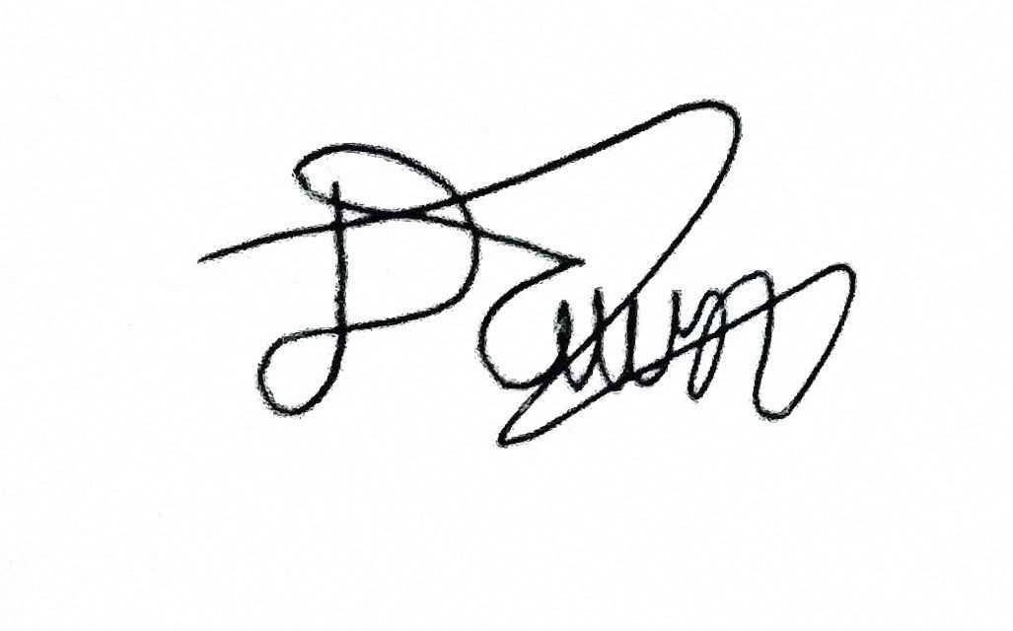
Rogelio Porras | 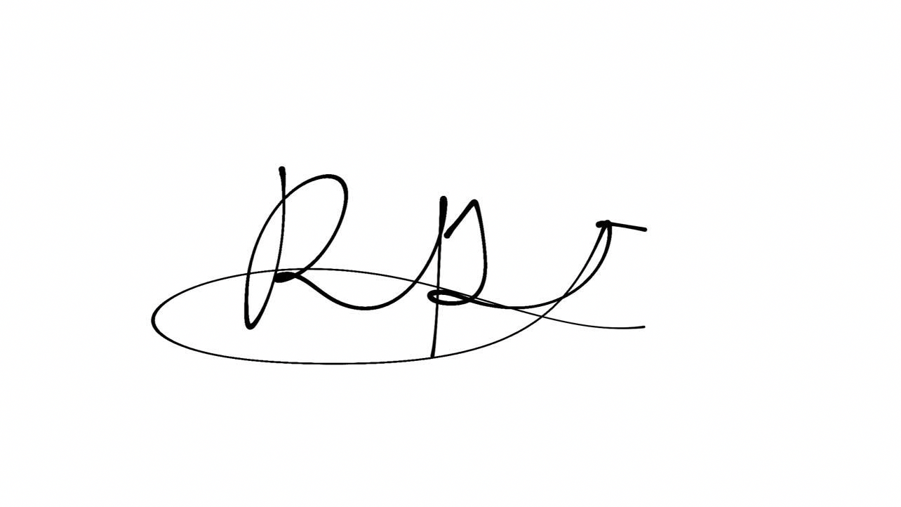
John Ashley Alba | 
Ralph Blanco | 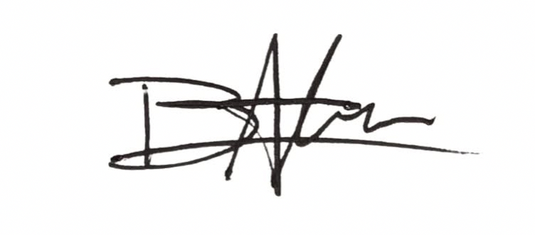

3. Team Contribution Matrix
The total contribution percentage must equal 100%.
Group Member | Assigned Task/Responsibility | Specific Contribution/Output | Contribution (%)
Dawn Andrei Pamesa | Project Manager; contacted V.M. Daet as the client and handled its questionnaire and data; planning with Ralph. | V.M. Daet client contact and questionnaire; planning and method design with Ralph; the proposal text, done with Claude and the custom GPT. | 30%
Rogelio Porras | Review of related literature and systems (RRL and RRS). | Sources and write-up for the RRL and RRS. | 23%
John Ashley Alba | Review of related literature and systems (RRL and RRS). | Sources and write-up for the RRL and RRS. | 23%
Ralph Blanco | Planning and brainstorming with the Project Manager. | Ideas and planning input for the proposal. | 24%
 |  | Total | 100%

